Lab: 1
Name: SOLOMON EWUSI | Student ID: N01659373
Date: SEPTEMBER 18, 2026

Please refer to the lab manual posted on the blackboard and fill in the blanks in the following table as your lab report.

Notice: All labs are individual work and submission. All academic misconduct behaviors will be penalized to the maximum extent possible according to college policy. Thanks for your attention. (Reference Link: About Academic Misconduct)

Fill in all the lab report submission requirements in the following table. Please add more rows if necessary.

Requirements | Your submissions (Answers/Source Code/Screenshots/File Submissions, etc.)  Please notice: If it is required to submit a separate file, please attach it separately on the blackboard.
Part 2 – Question 1 | 1a. 1 byte = 8 bits  1b. 1M bytes = 1,048,576 bytes (2²⁰)  1c. 1.5G bytes = 1,610,612,736 bytes (1.5 × 2³⁰)  1d. 1.8T bytes = 1,979,120,929,997 bytes (1.8 × 2⁴⁰)  1e. Period of a 2GHz clock = 1 / (2 × 10⁹ Hz) = 0.5 nanoseconds
Part 2 – Question 2 | a. DRAM: Dynamic Random Access Memory  b. DDR: Double Data Rate  c. CPU: Central Processing Unit  d. CMOS: Complementary Metal-Oxide-Semiconductor  e. USB: Universal Serial Bus
Your source code (in C programming language) | Please submit the source code as a separate .c file.
The running results of your code
Data Type | Your definition example of the corresponding variable in your code (refer to the example in the first row) | Size of the data type running on onlinegdb.com | Size of the data type running on the local PC
char | char a; | 1 | 1
short | short b; | 2 | 2
int | int c; | 4 | 4
long | long d; | 8 | 4
float | float e; | 4 | 4
double | double f; | 8 | 8
A pointer to int | int *pInt; | 8 | 4
A pointer to long | long *pLong; | 8 | 4
A pointer to float | float *pFloat; | 8 | 4
A pointer to double | double *pDouble; | 8 | 4
struct Account defined above | struct Account acc; | 40 | 28
A pointer to the struct Account | struct Account *pAcc; | 8 | 4

Screenshot of the running  results of your code | - Running results on onlinegdb.com — 64-bit environment (long and pointers = 8 bytes)  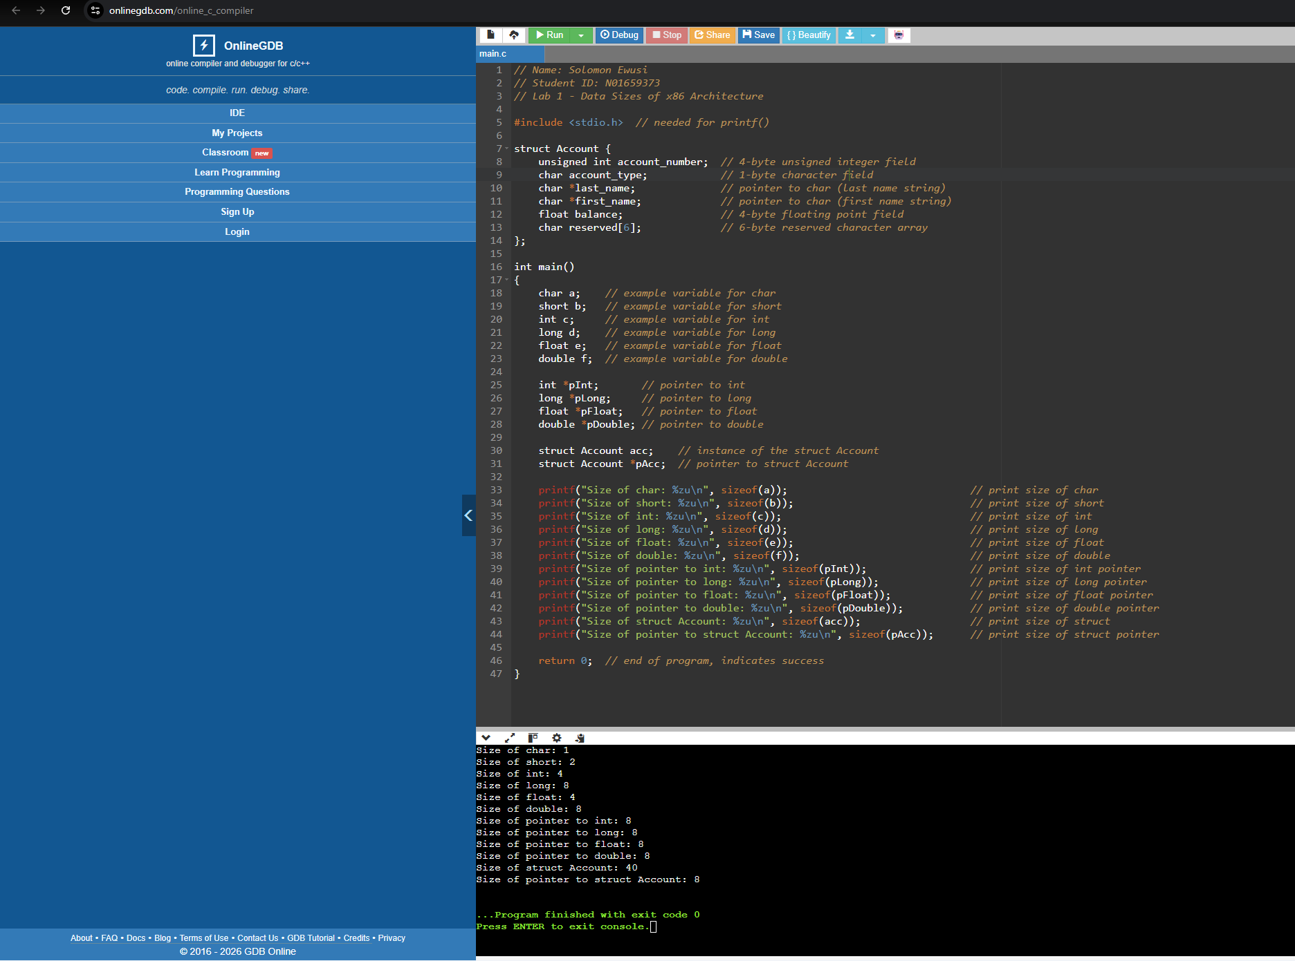  - Running results on local PC — 32-bit MinGW environment (long and pointers = 4 bytes)  